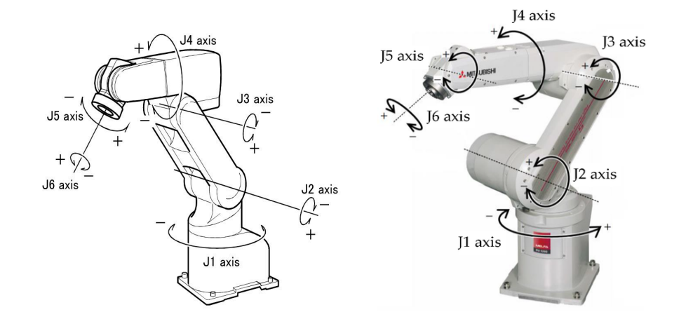

Figure 1: Mitsubishi RV-8CRL Industrial Robot.

Expt No:  08 | MITSUBISHI 6-AXIS ROBOT
Date:
/ /2025

AIM:
To become familiar with the fundamental jog controls and coordinate systems of a Mitsubishi 6-axis industrial robot using the teaching pendant.

APPARATUS REQUIRED:
- Robot: Mitsubishi 6-axis serial manipulator (e.g., RV-8CRL),
- Controller: Mitsubishi Robot Controller,
- Teach Pendant: Mitsubishi Teaching Pendant,
- Work Cell: Safety barriers.

THEORY / PRINCIPLE OF OPERATION:
This experiment focuses on the fundamental manual control (jogging) of a 6-axis serial manipulator, which is the prerequisite for any programming or setup task. The key concept is understanding the different Coordinate Systems or Reference Frames used to move the robot.
- JOINT Mode: This is the most basic mode. It allows the operator to control each of the 6 joints (J1-J6) individually. This motion is not intuitive for the end-effector (TCP), as moving J2 (shoulder) or J3 (elbow) will cause the TCP to move in an arc.
- XYZ (or WORLD) Mode: This is a Cartesian mode. The operator commands motion in the X, Y, or Z directions relative to the robot's fixed base. It performs the Inverse Kinematics (IK) calculations to coordinate all joints (J1-J3) to move the TCP in a straight line.
- TOOL Mode: This is the most critical mode for any end-effector task. It is also a Cartesian mode, but the X, Y, and Z axes are relative to the end-effector (tool) itself. In this mode, +Z will always move the tool "outward" along its own axis, regardless of its orientation in space. This is essential for tasks like inserting a bolt or approaching a surface at an angle.

PROCEDURE:
- The robot was powered on, and the controller was set to TEACH mode via the key switch.
- The JOG key was pressed on the pendant to enter jog mode. The deadman switch on the back of the pendant was held to enable servo power.
- JOINT Mode:
  - JOINT mode was selected. The [J1] key was pressed, and the [+] and [-] keys were used.
  - This was repeated for all six axes (J1 through J6) to understand the individual motion of each joint.
- XYZ (Cartesian) Mode:
  - The jog mode was switched to XYZ.
  - The [X+] and [X-] keys were pressed.
  - This was repeated for the [Y] and [Z] axes.
- TOOL Mode:
  - The jog mode was switched to TOOL.
  - The [X+], [Y+], and [Z+] keys were pressed.
- Speed Control: The [OVRD] (Override) keys were used to adjust the jogging speed percentage, and the change was verified on the pendant's display.
- Safety Validation:
  - While jogging an axis, the deadman switch was released.
  - The Emergency Stop button was pressed.

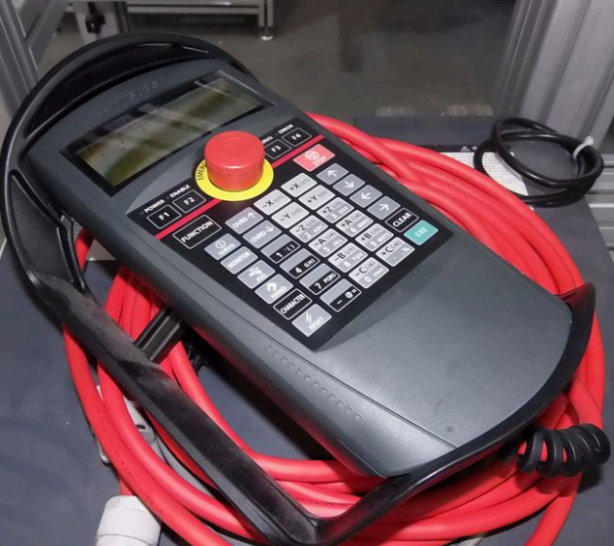

Figure 2: Mitsubishi Teaching Pendent.

RESULT:
The fundamental jogging controls of the Mitsubishi 6-axis robot were successfully studied. The experiment provided a clear, practical understanding of the critical differences between the Joint, XYZ (World), and Tool coordinate systems and the practical application of each for manual robot manipulation.

